

Title [1° Congresso Nazionale Divisione Chimica per le Tecnologie SCI – 2022](http://www.sisn.it/xxxii-congresso-annuale-sisn-7-e-8-ottobre-2021/) (Times New Roman 16)

**Name1 Surname1**,1,* Name2 Surname2,2 Name3 Surname3,3 (Times New Roman 12)

1 Affiliation1 (Times New Roman 10)

2 Affiliation2 (Times New Roman 10)

3 Affiliation2 (Times New Roman 10)

*e-mail: presenter_TimesNewRoman10@xx.it

Please fill this file following the instruction.1

The abstract is written in English. It must not exceed one page, including figures and references. (Text Times New Roman 12) (Figure 1).2

Please rename the Microsoft Word file (.doc or .docx) as “Surname_Name” and send it using the form available on the Congress website (www.dicmapi.unina.it/cpt2022).

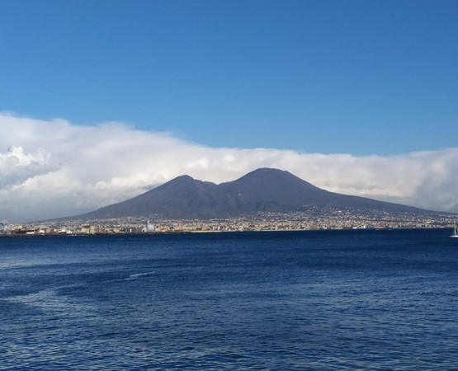

**Figure 1.** Picture of Vesuvio (Times New Roman 10).

*References*

[1] Surname, N., …..Title. *Journal* Year, issue, volume, page1-pagefinal.

[2] Surname, N., …..Title. *Journal* Year, issue, volume, page1-pagefinal.